**LAB RECORD (OOJ LAB 2020)**

**TEST-1**

NAME:TRISHA LAKHANI

USN:1BM19CS214

SECTION:3 D

**Lab Program 1** : **Develop a Java program that prints all real solutions to the quadratic equation ax2 +bx+c = 0. Read in a, b, c and use the quadratic formula. If the discriminate b2-4ac is negative, display a message stating that there are no real solutions.**

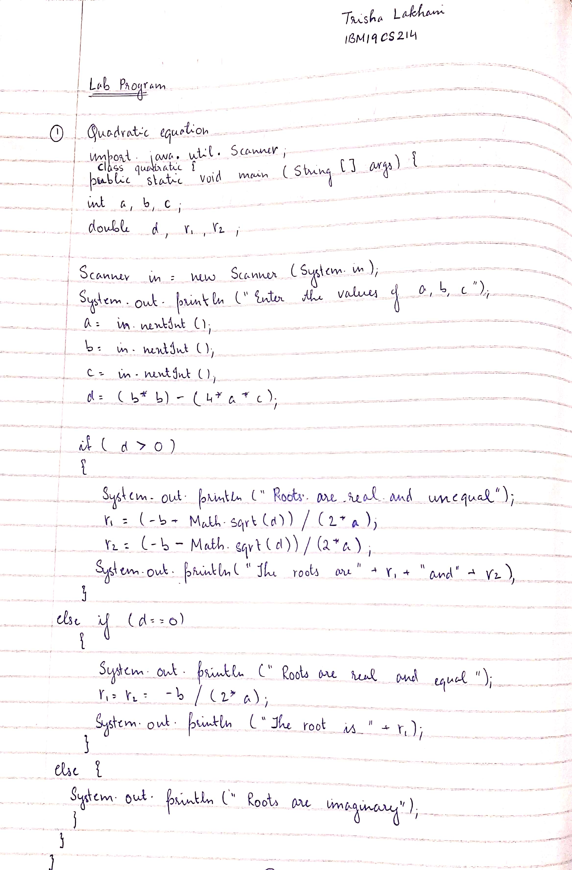

import java.util.Scanner;

public class quadratic{

public static void main(String[] args){

int a,b,c;

double d,r1,r2;

Scanner in=new Scanner(System.in);

System.out.println("Enter the values of a,b,c");

a=in.nextInt();

b=in.nextInt();

c=in.nextInt();

d=(b*b)-(4*a*c);

if(d>0)

{

System.out.println("roots are real and unequal");

r1=(-b+Math.sqrt(d))/(2*a);

r2=(-b-Math.sqrt(d))/(2*a);

System.out.println("The roots are " + r1 + " and " + r2);

}

else if(d == 0)

{

System.out.println("roots are real and equal");

r1 = r2 = -b / (2 * a);

System.out.println("The root is " + r1);

}

else

{

System.out.println("roots are imaginary and no real solution exists");

}

}

}

**OUTPUT**

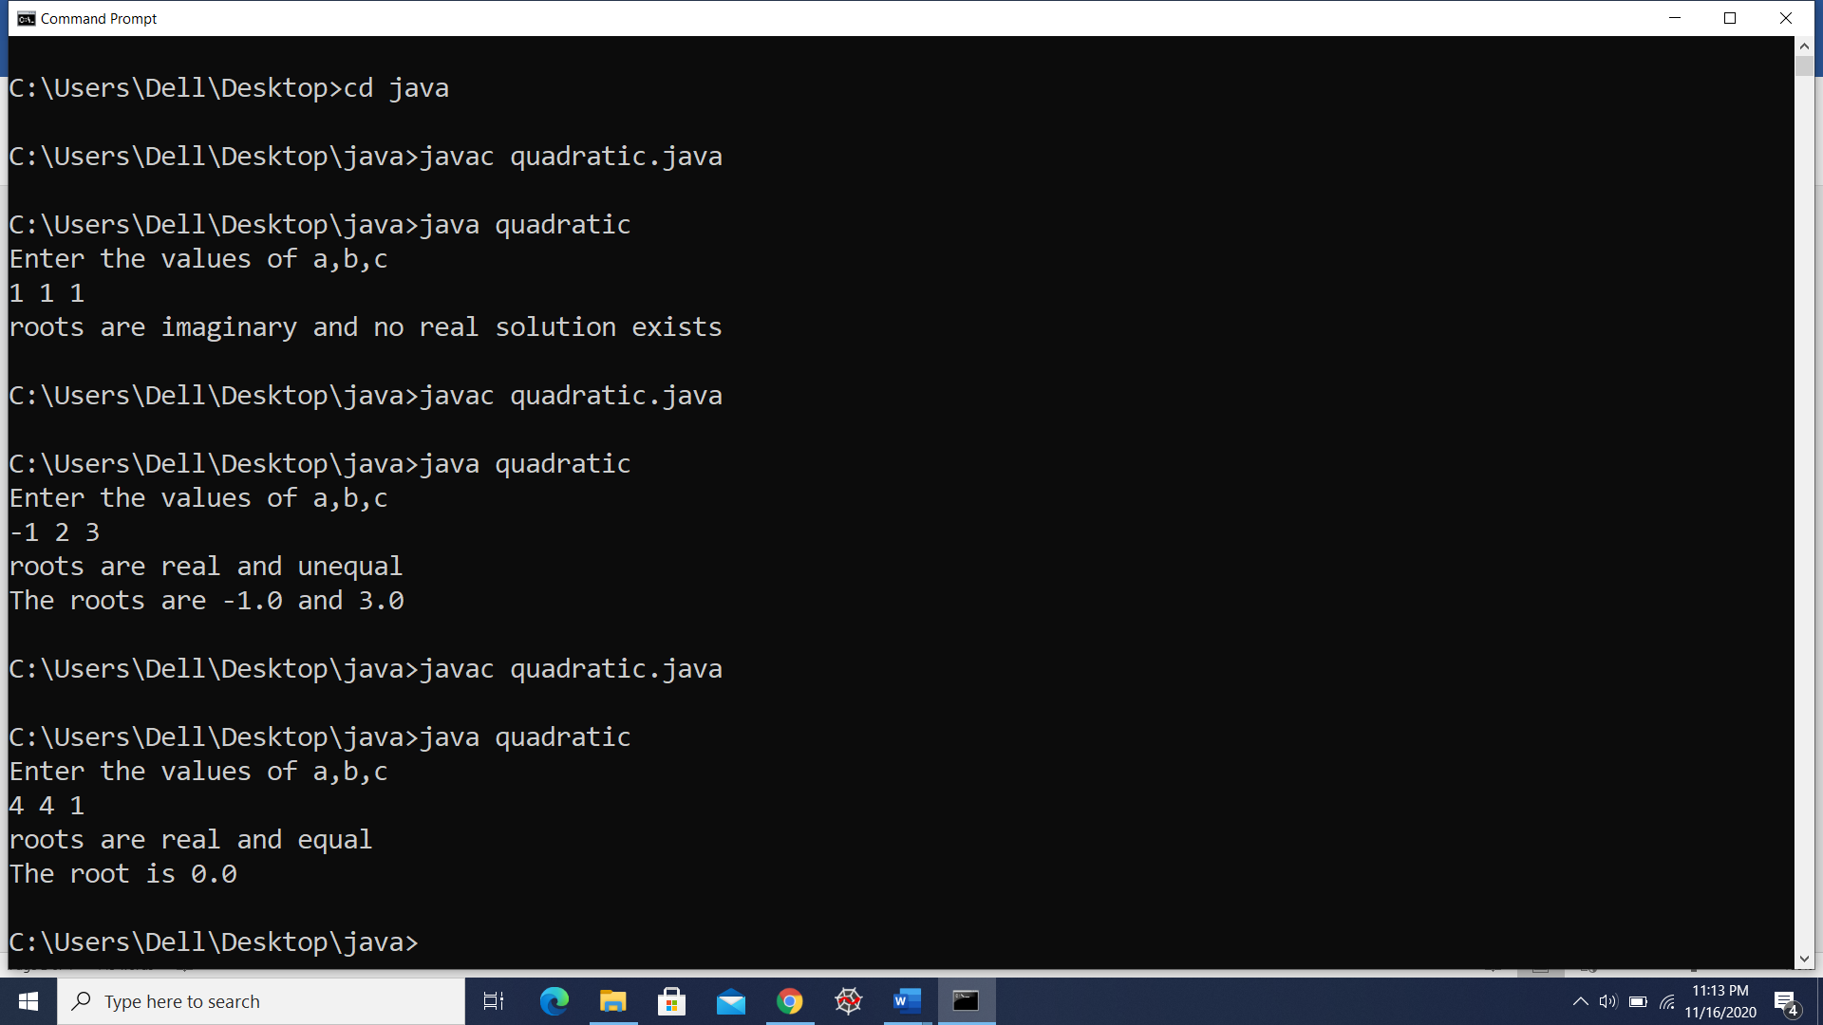

**Lab Program 2:** **Develop a Java program to create a class Student with members usn, name, an array** **credits and an array marks. Include methods to accept and display details and a method to** **calculate SGPA of a student.**

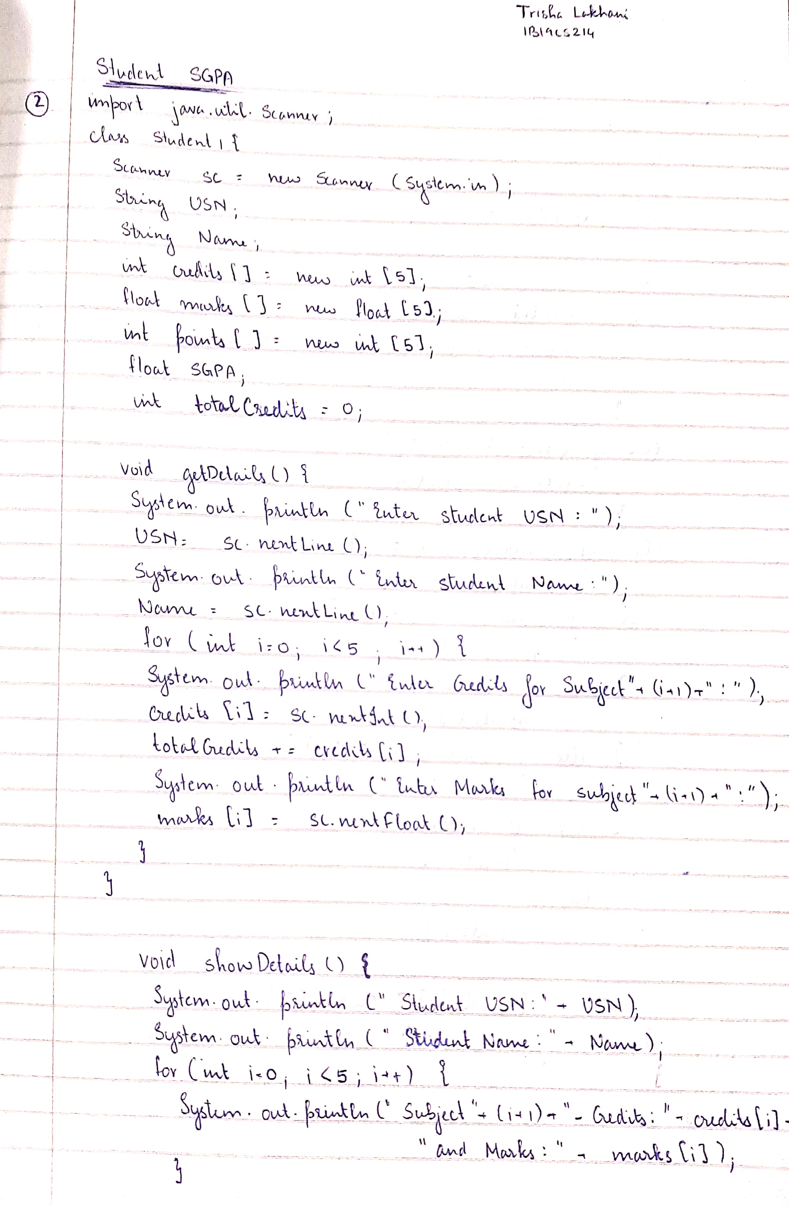

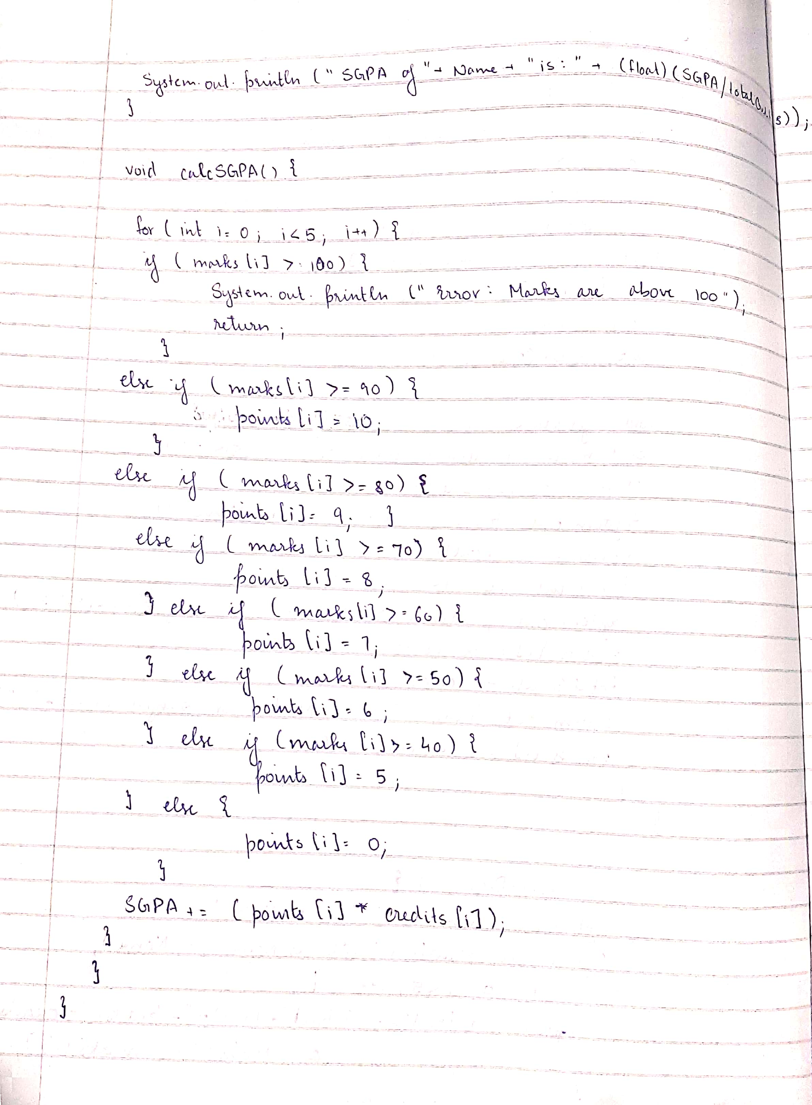

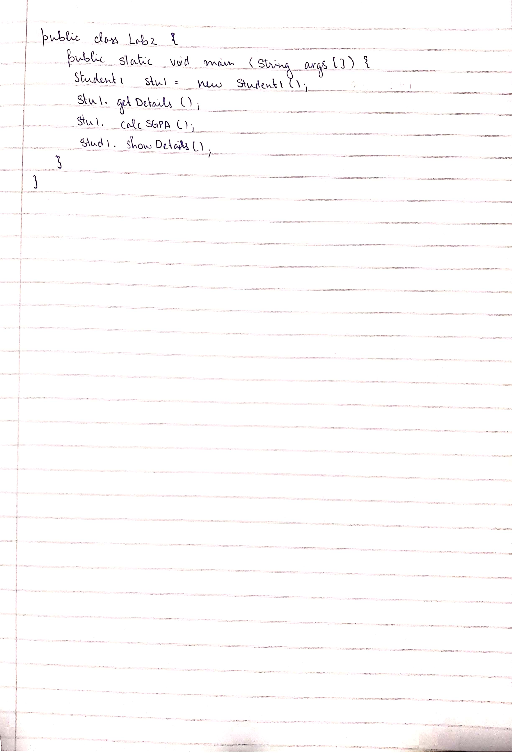

import java.util.Scanner;

class Stud{

Scanner in = new Scanner(System.in);

String USN;

String Name;

int credits[] = new int[5];

float marks[] = new float[5];

int gradepoints[] = new int[5];

float SGPA;

int totalCredits = 0;

void getDetails(){

System.out.println("Enter student USN: ");

USN = in.nextLine();

System.out.println("Enter student Name: ");

Name = in.nextLine();

for(int i=0;i<5;i++){

System.out.println("Enter Credits for Subject " + (i+1) + ": ");

credits[i] = in.nextInt();

totalCredits += credits[i];

System.out.println("Enter Marks for Subject " + (i+1) + ": ");

marks[i] = in.nextFloat();

}

}

void showDetails(){

System.out.println("Student USN: " + USN);

System.out.println("Student name: " + Name);

for(int i=0;i<5;i++){

System.out.println("Subject " + (i+1) + " - Credits: " + credits[i] + " and Marks: " + marks[i]);

}

System.out.println("SGPA of " + Name + " is: " + (float)(SGPA/totalCredits));

}

void calcSGPA(){

for(int i = 0;i<5;i++){

if(marks[i] > 100){

System.out.println("Error: Marks are above 100");

return;

}else if(marks[i] >= 90){

gradepoints[i] = 10;

}else if(marks[i] >= 80){

gradepoints[i] = 9;

}else if(marks[i] >= 70){

gradepoints[i] = 8;

}else if(marks[i] >= 60){

gradepoints[i] = 7;

}else if(marks[i] >= 50){

gradepoints[i] = 6;

}else if(marks[i] >= 40){

gradepoints[i] = 5;

}else{

gradepoints[i] = 0;

}

SGPA = SGPA+(gradepoints[i]*credits[i]);

}

}

}

public class Lab2 {

public static void main(String args[]) {

Stud stu1 = new Stud();

stu1.getDetails();

stu1.calcSGPA();

stu1.showDetails();

}

}

**OUTPUT**

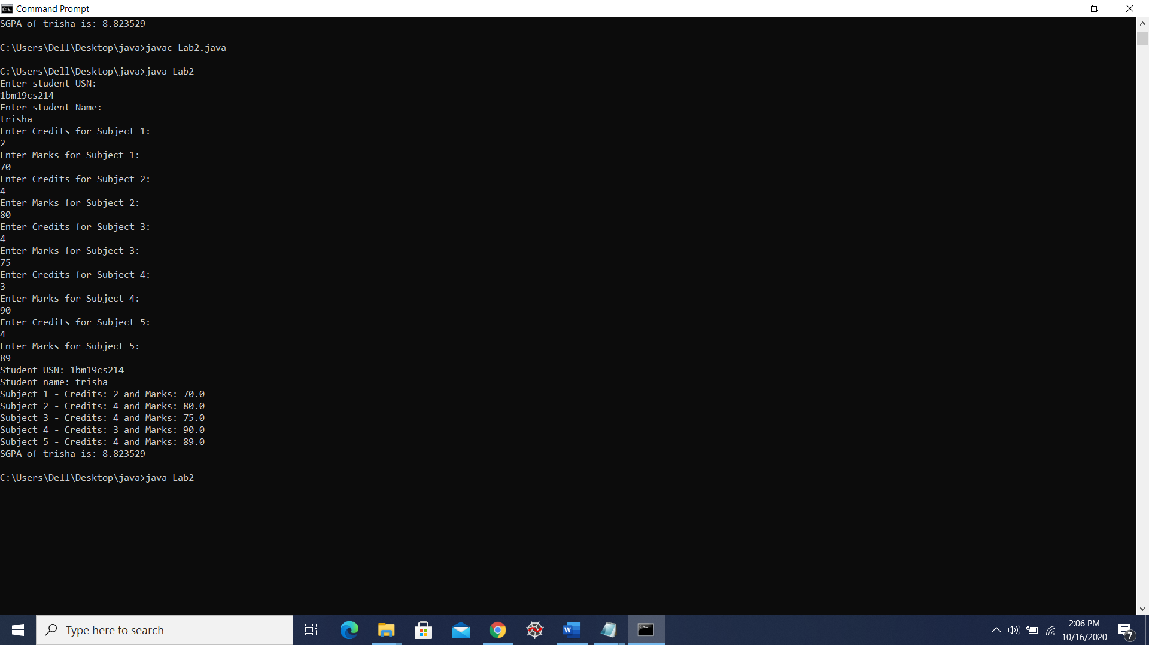

**LAB PROGRAM 3:** **Create a class Book which contains four members: name, author, price, num_pages. Include a constructor to set the values for the members. Include methods to set and get the details of the objects. Include a toString( ) method that could display the complete details of the book. Develop a Java program to create n book objects.**

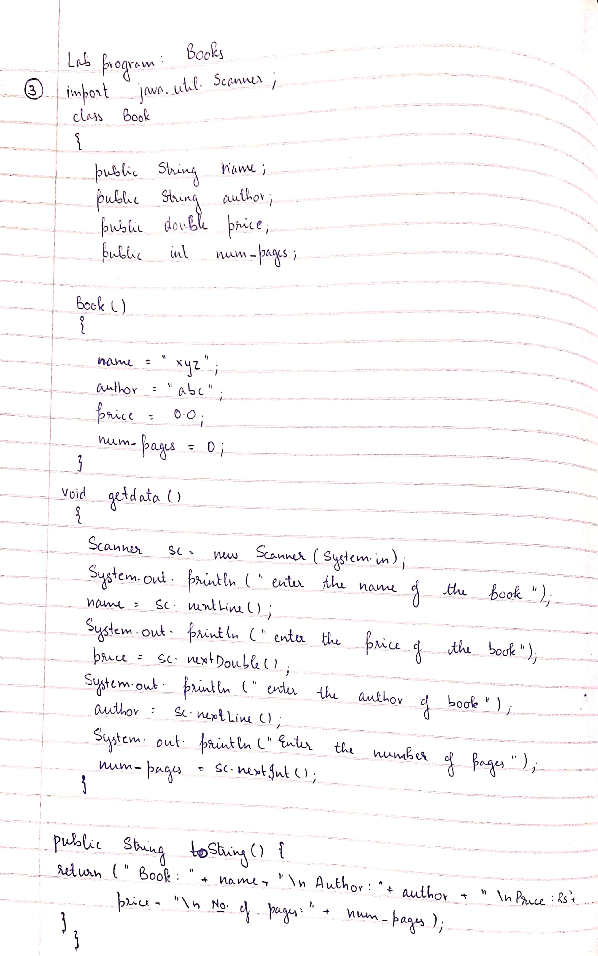

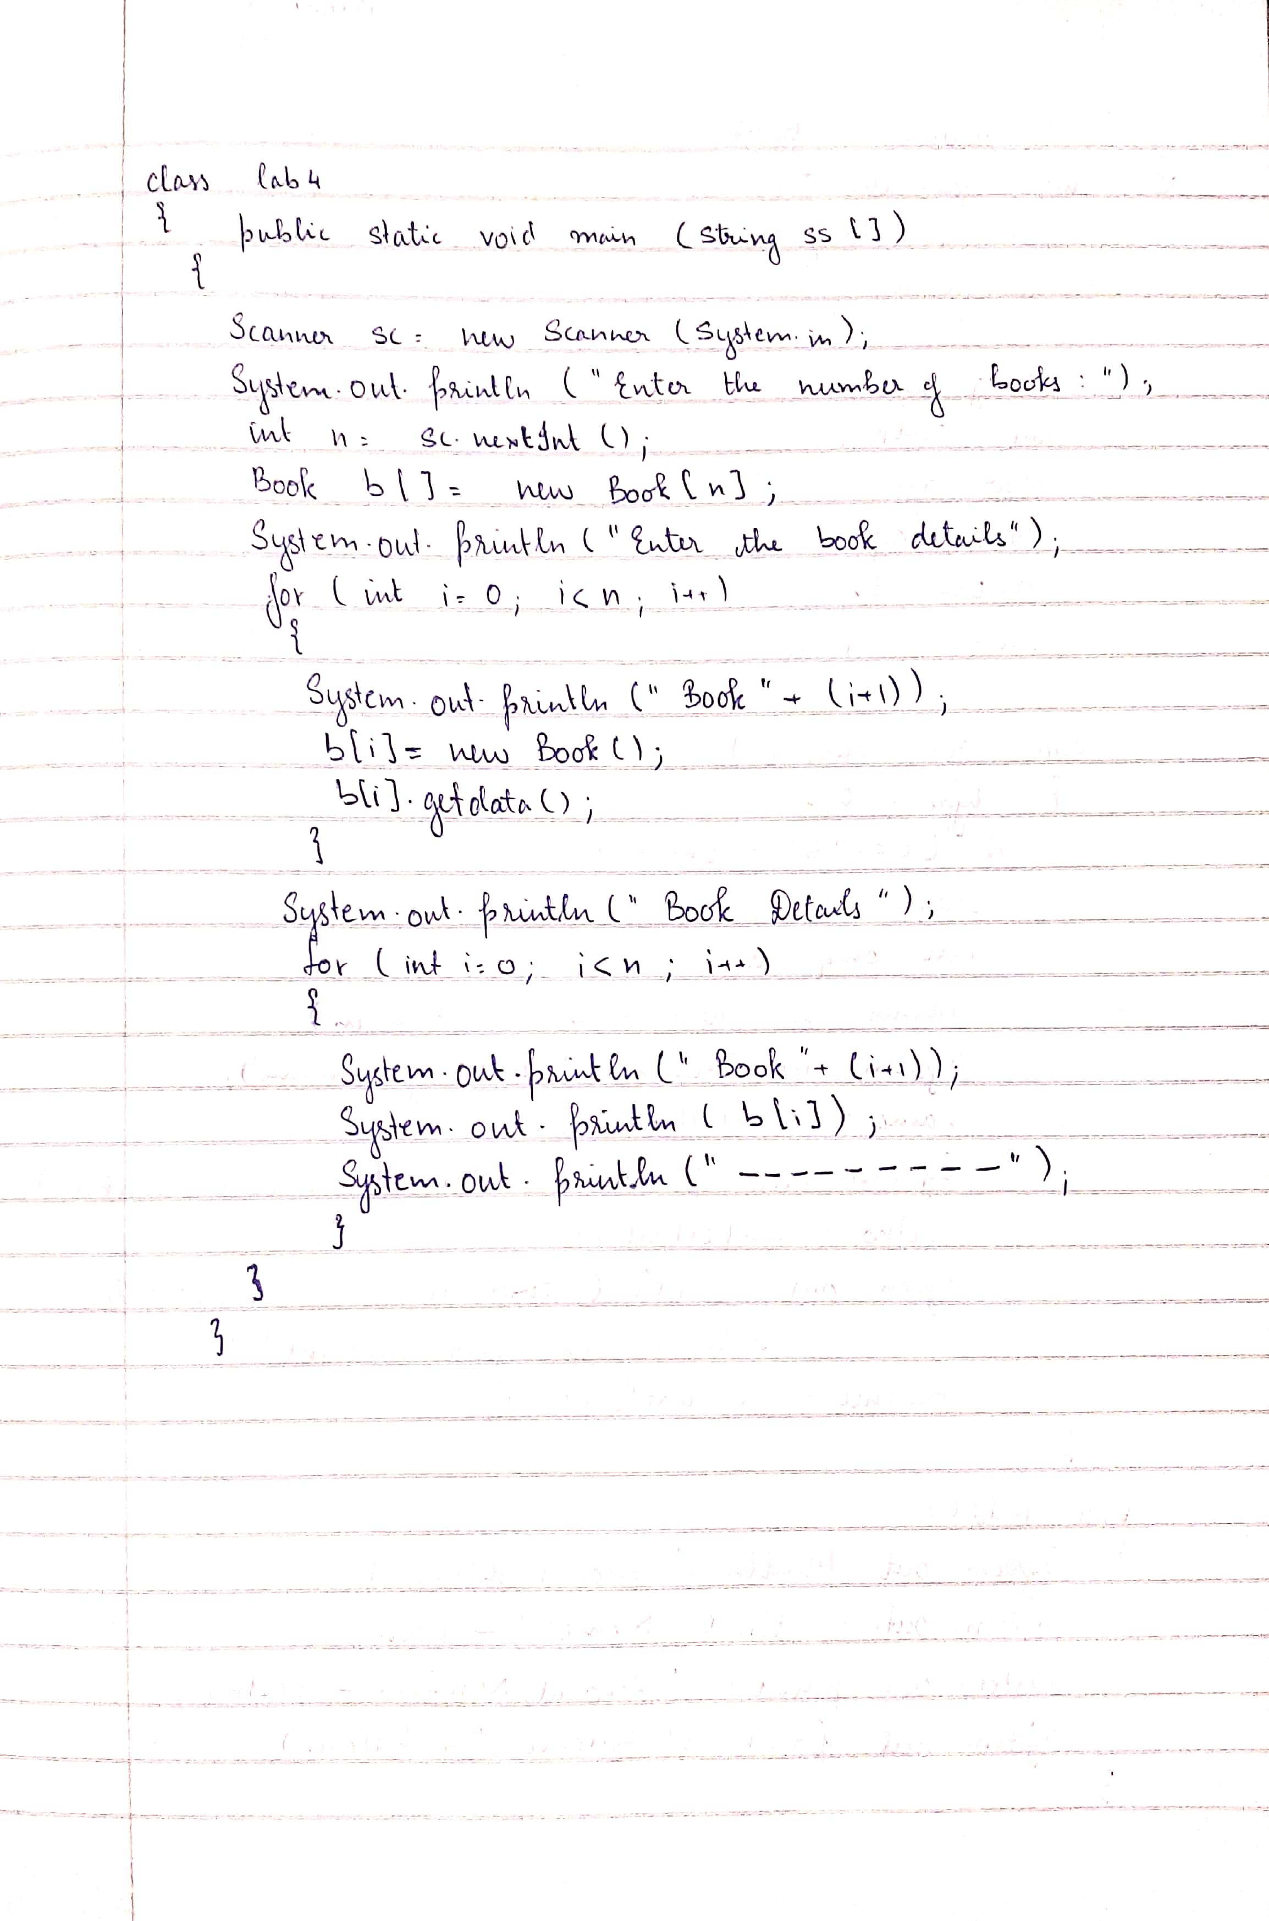

import java.util.*;

class Book

{

public String name;

public String author;

public double price;

public int num_pages;

Book()

{

name="xyz";

author="abc";

price= 0.0;

num_pages=0;

}

void getdata()

{

Scanner sc= new Scanner(System.in);

System.out.println("enter the name of book");

name = sc.nextLine();

System.out.println("enter the name of author");

author = sc.nextLine();

System.out.println("enter the price of book");

price = sc.nextDouble();

System.out.println("enter the number of pages");

num_pages = sc.nextInt();

}

public String toString()

{

return("Book: "+name+"\nAuthor: "+author+"\nPrice: Rs "+price+"\nNo.of pages: "+num_pages);

}

}

class lab3

{

public static void main(String ss[])

{

Scanner sc=new Scanner(System.in);

System.out.println("Enter the number of books:");

int n=sc.nextInt();

Book b[]=new Book[n];

int i;

System.out.println("Enter the book details");

for(i=0;i<n;i++)

{

System.out.println("Book "+(i+1));

b[i]=new Book();

b[i].getdata();

}

System.out.println(" Book details....");

for(i=0;i<n;i++)

{

System.out.println("Book "+(i+1));

System.out.println(b[i]);

System.out.println("-----------------------");

}

}

}

**OUTPUT**

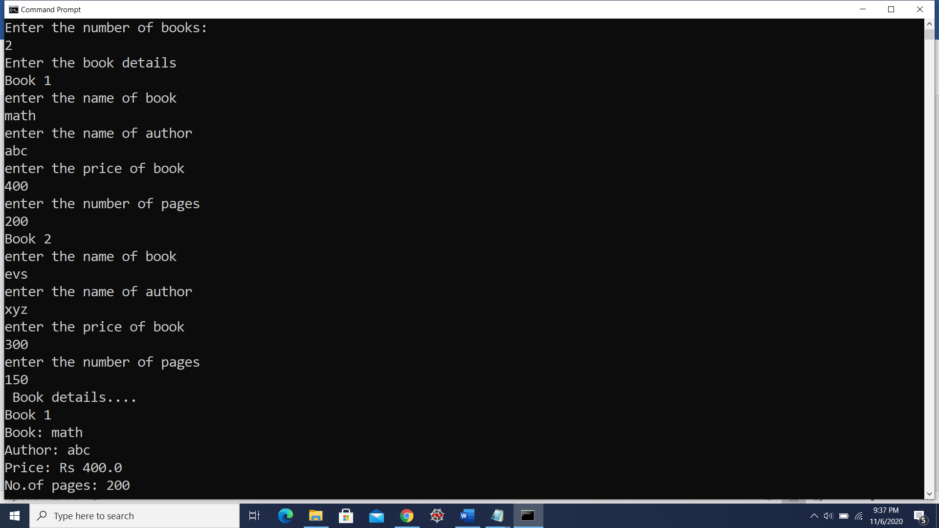

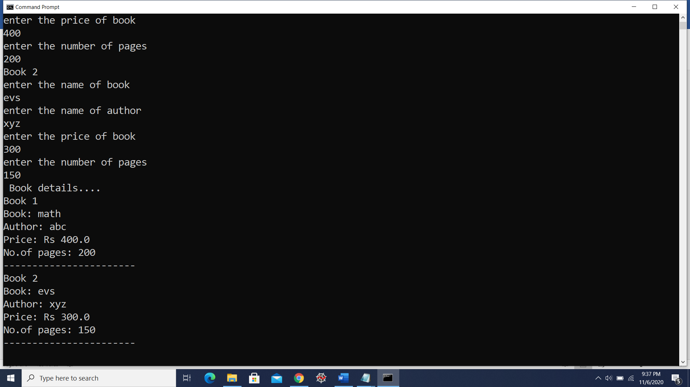

**LAB PROGRAM 4:** **Develop a Java program to create an abstract class named Shape that contains two integers and an empty method named printArea( ). Provide three classes named Rectangle, Triangle and Circle such that each one of the classes extends the class Shape. Each one of the classes contain only the method printArea( ) that prints the area of the given shape.**

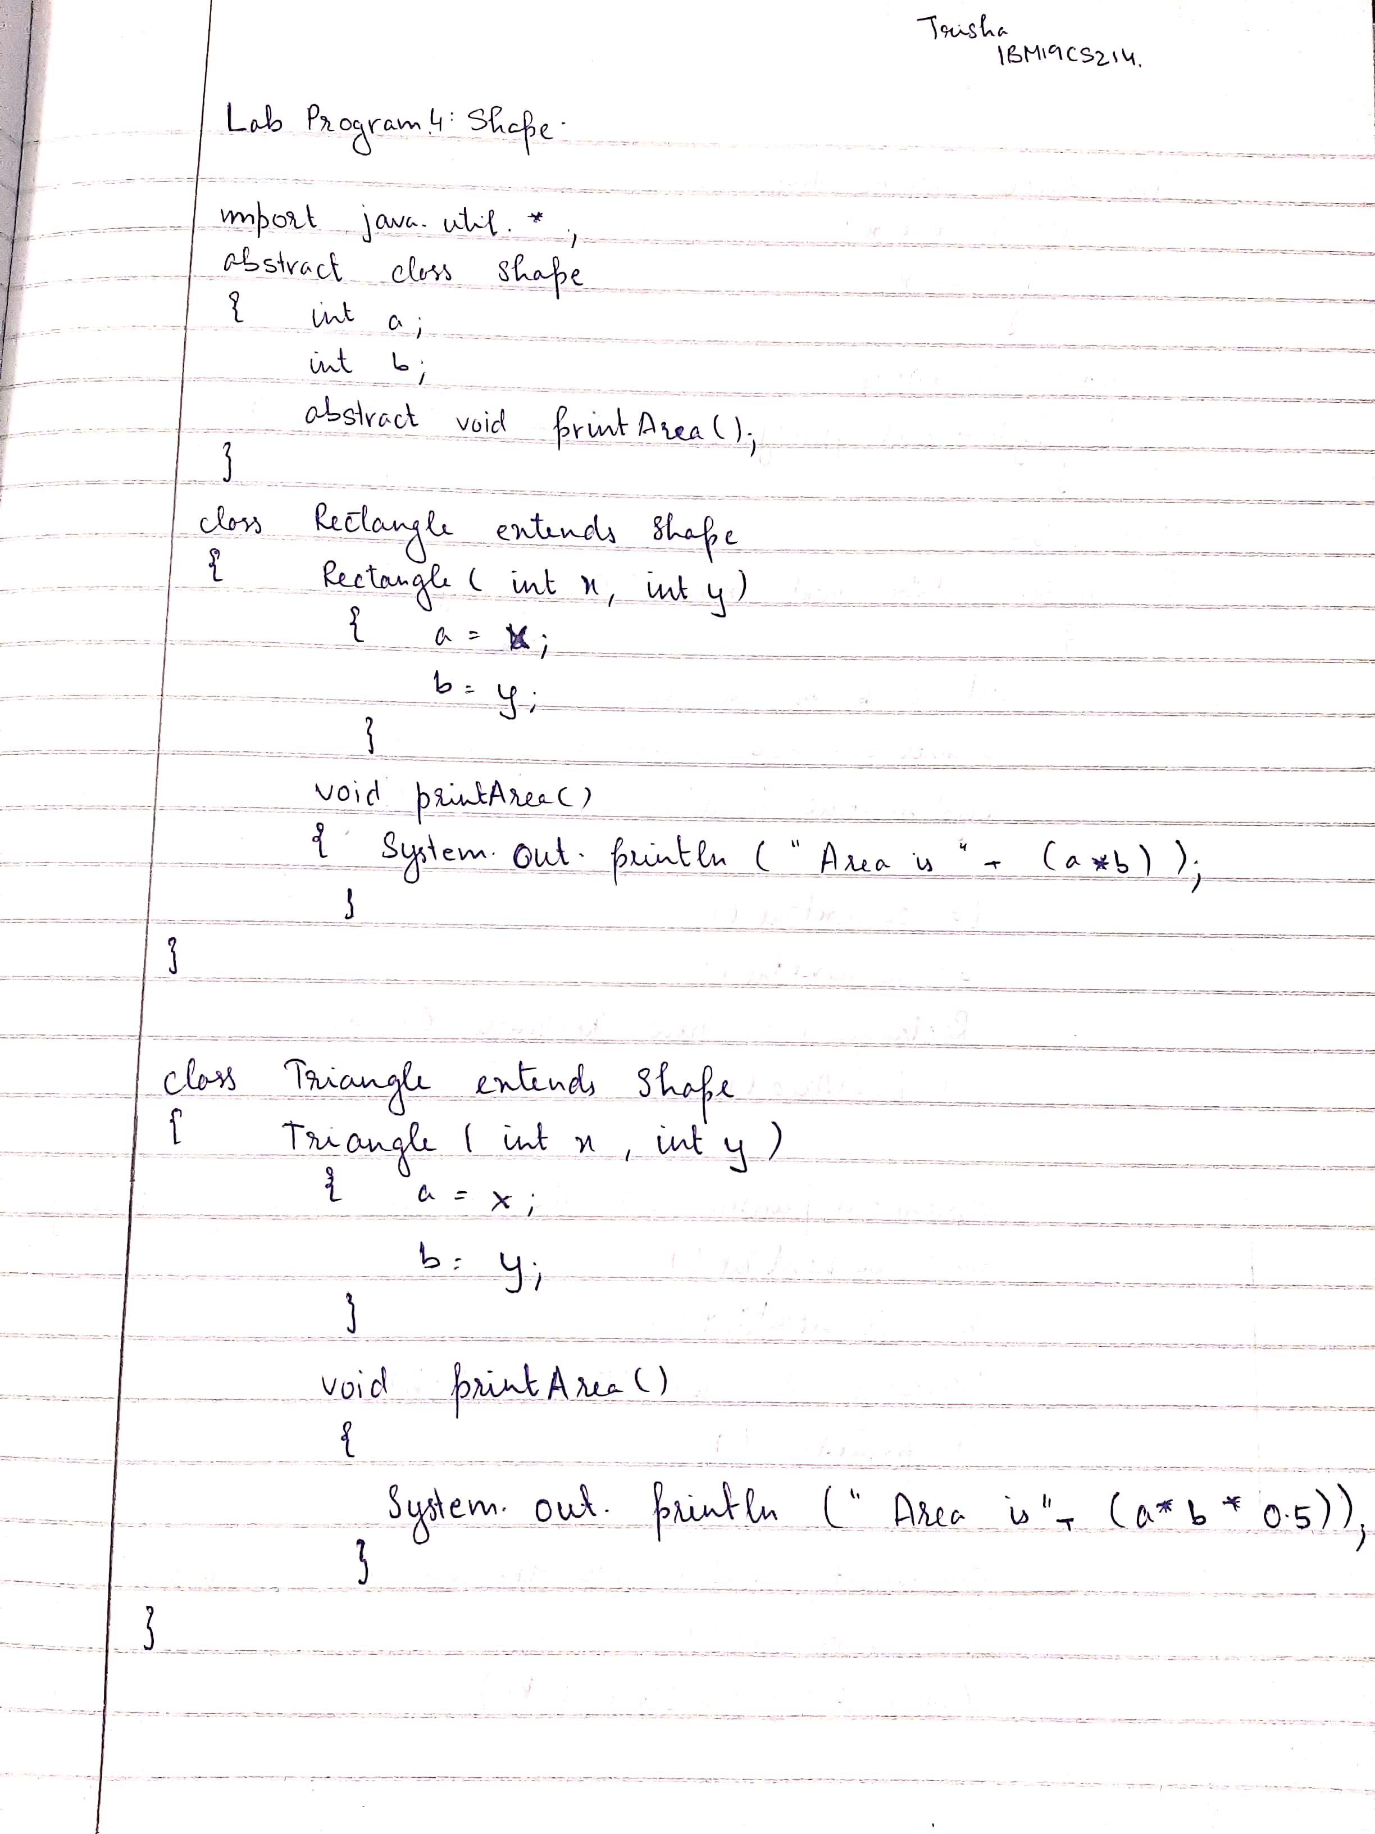

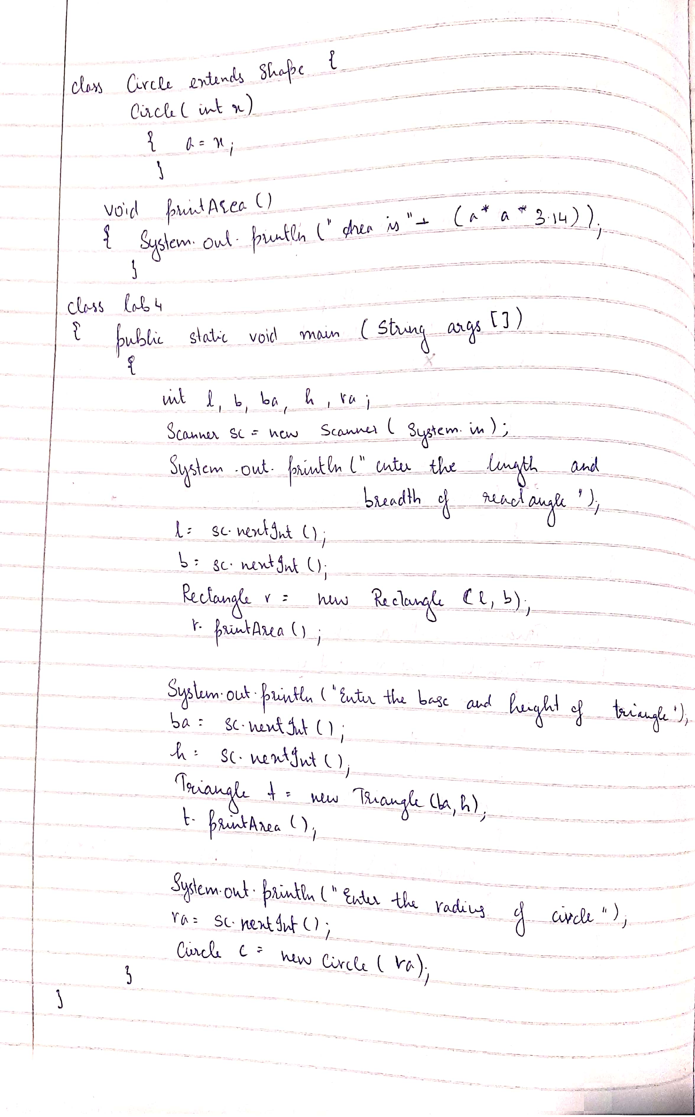

import java.util.*;

abstract class Shape

{

int a;

int b;

abstract void printArea();

}

class Rectangle extends Shape

{

Rectangle(int x, int y)

{

a=x;

b=y;

}

void printArea()

{

System.out.println("Area is "+(a*b));

}

}

class Triangle extends Shape

{

Triangle(int x, int y)

{

a=x;

b=y;

}

void printArea()

{

System.out.println("Area is "+(a*b*0.5));

}

}

class Circle extends Shape

{

Circle(int x)

{

a=x;

}

void printArea()

{

System.out.println("Area is "+(a*a*3.14));

}

}

class lab5

{

public static void main(String ss[])

{

int l,b,ba,h,ra;

Scanner sc = new Scanner(System.in);

System.out.println("enter the length and breadth of rectangle");

l= sc.nextInt();

b= sc.nextInt();

Rectangle r= new Rectangle(l,b);

r.printArea();

System.out.println("enter the base and height of triangle");

ba= sc.nextInt();

h= sc.nextInt();

Triangle t = new Triangle(ba,h);

t.printArea();

System.out.println("enter the radius of circle");

ra= sc.nextInt();

Circle c = new Circle(ra);

c.printArea();

}

}

**OUTPUT**

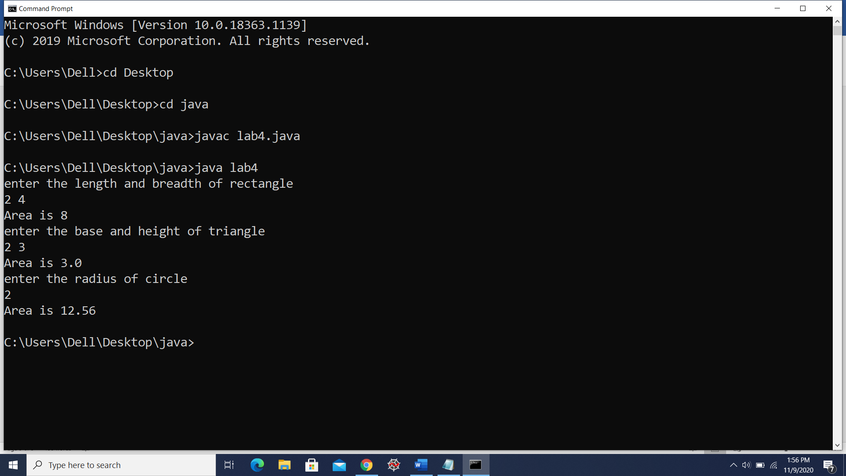

**LAB PROGRAM 5:** **Develop a Java program to create a class Bank that maintains two kinds of account for its customers, one called savings account and the other current account. The savings account provides compound interest and withdrawal facilities but no cheque book facility. The current account provides cheque book facility but no interest. Current account holders should also maintain a minimum balance and if the balance falls below this level, a service charge is imposed. Create a class Account that stores customer name, account number and type of account. From this derive the classes Curr-acct and Sav-acct to make them more specific to their requirements. Include the necessary methods in order to achieve the following tasks:**

**a) Accept deposit from customer and update the balance.**

**b) Display the balance.**

**c) Compute and deposit interest**

**d) Permit withdrawal and update the balance**

**Check for the minimum balance, impose penalty if necessary and update the balance.**

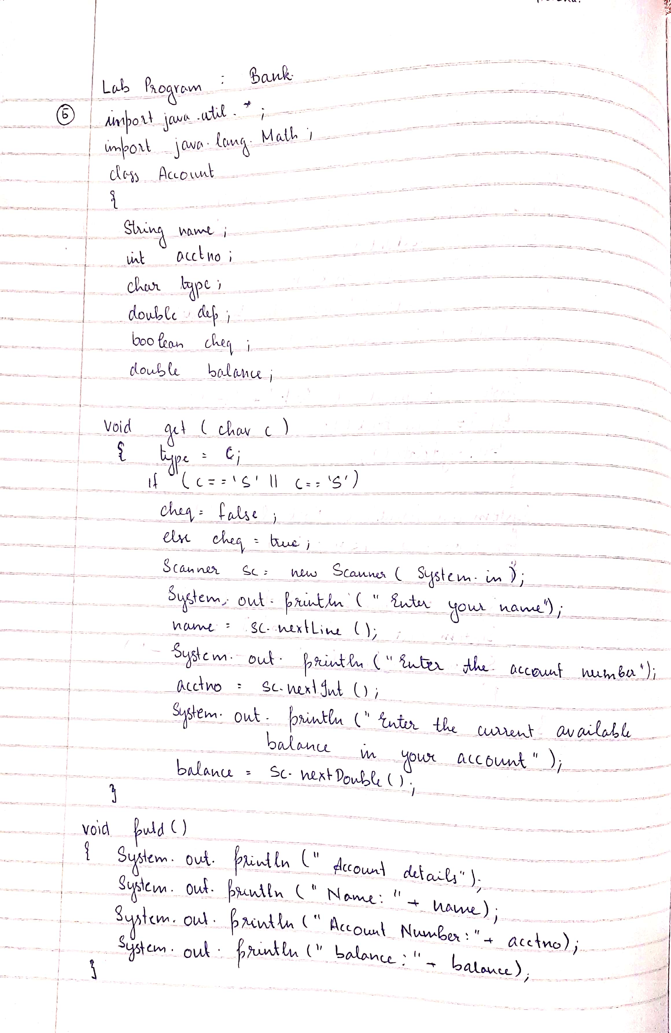

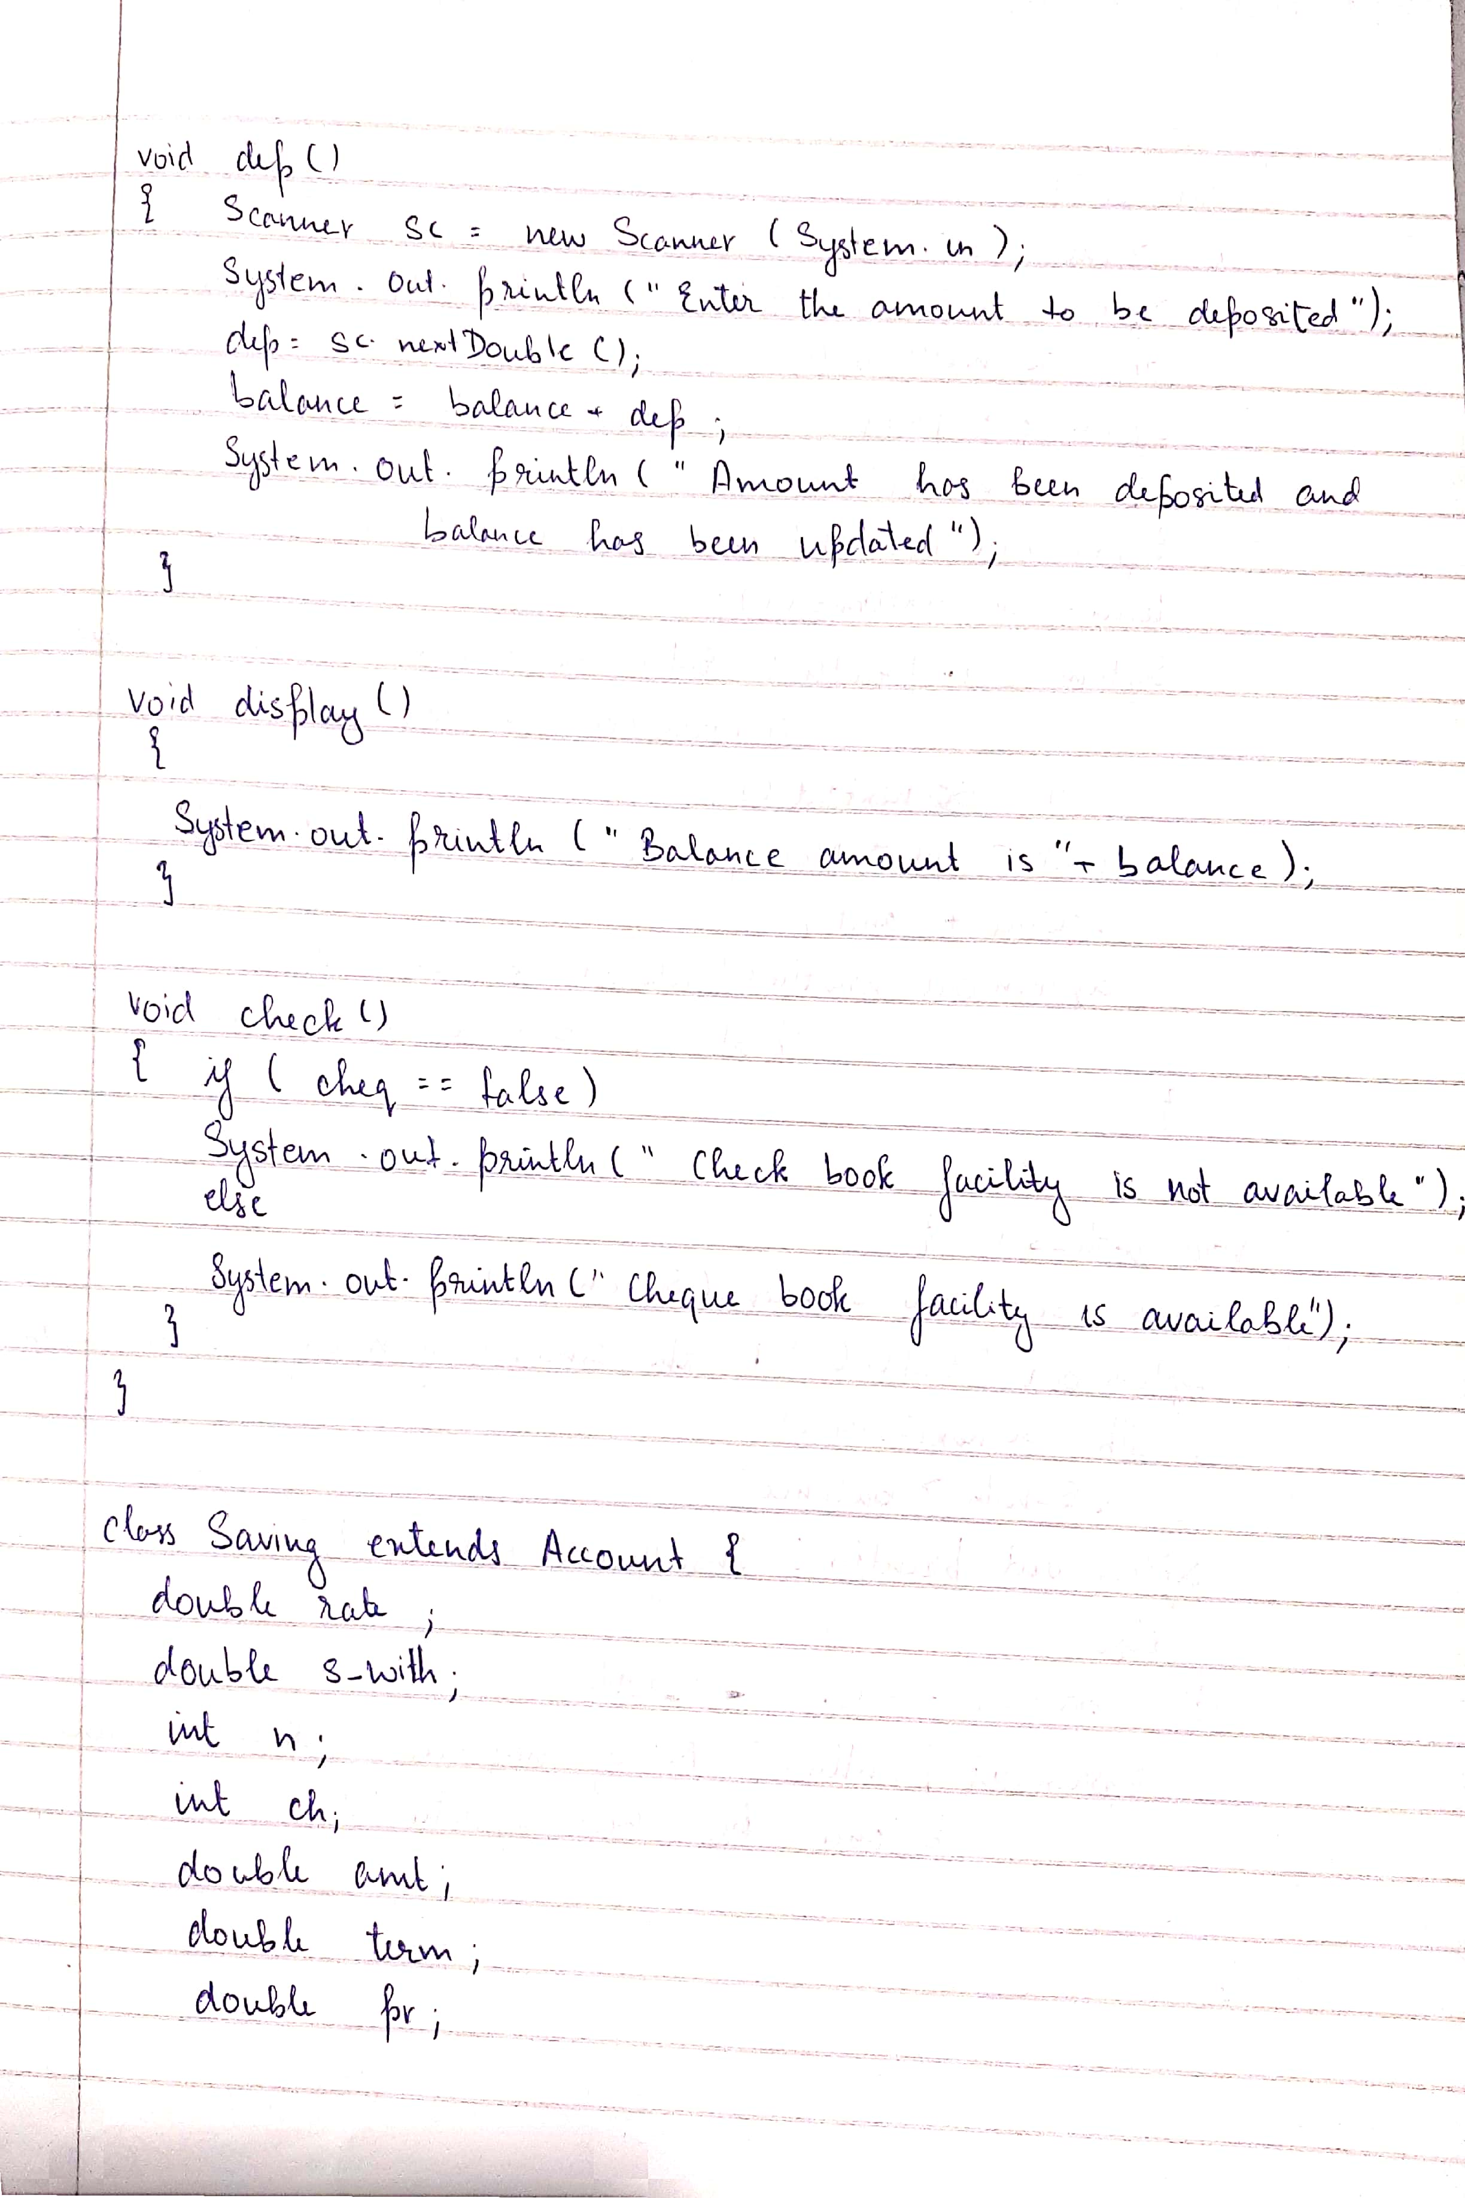

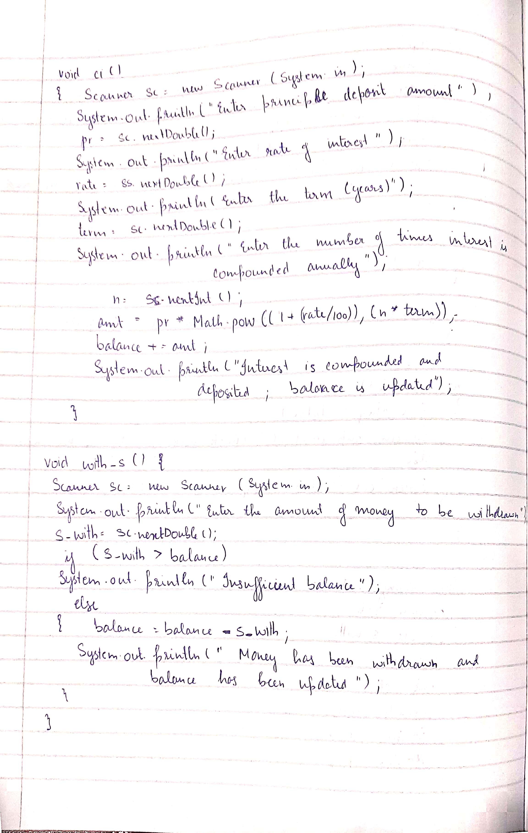

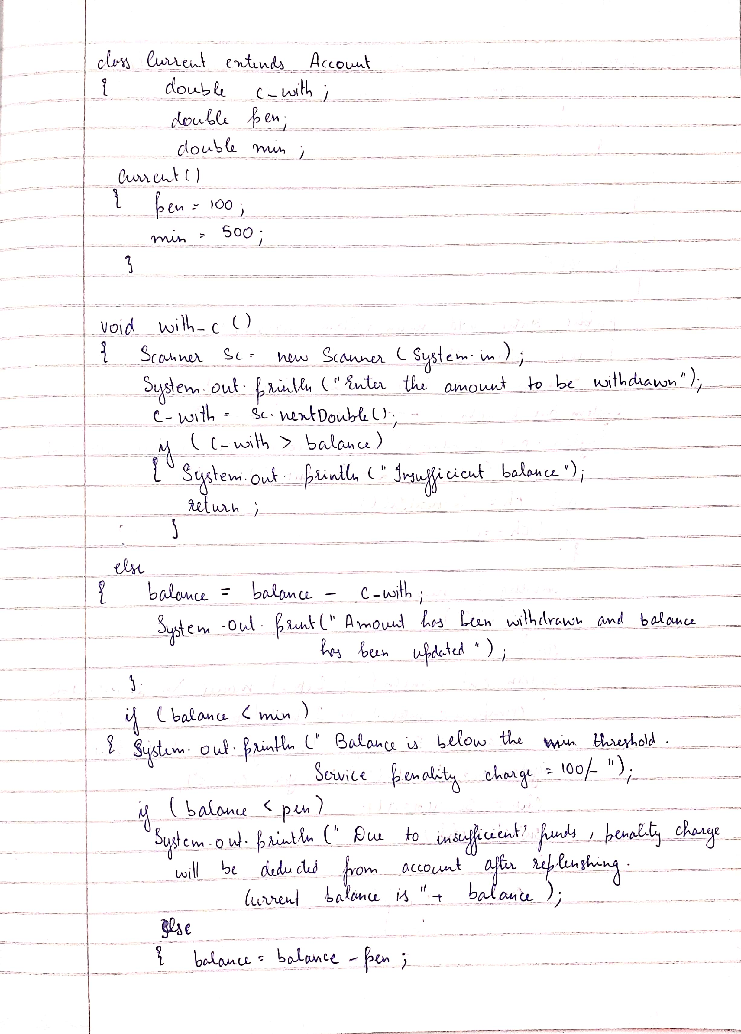

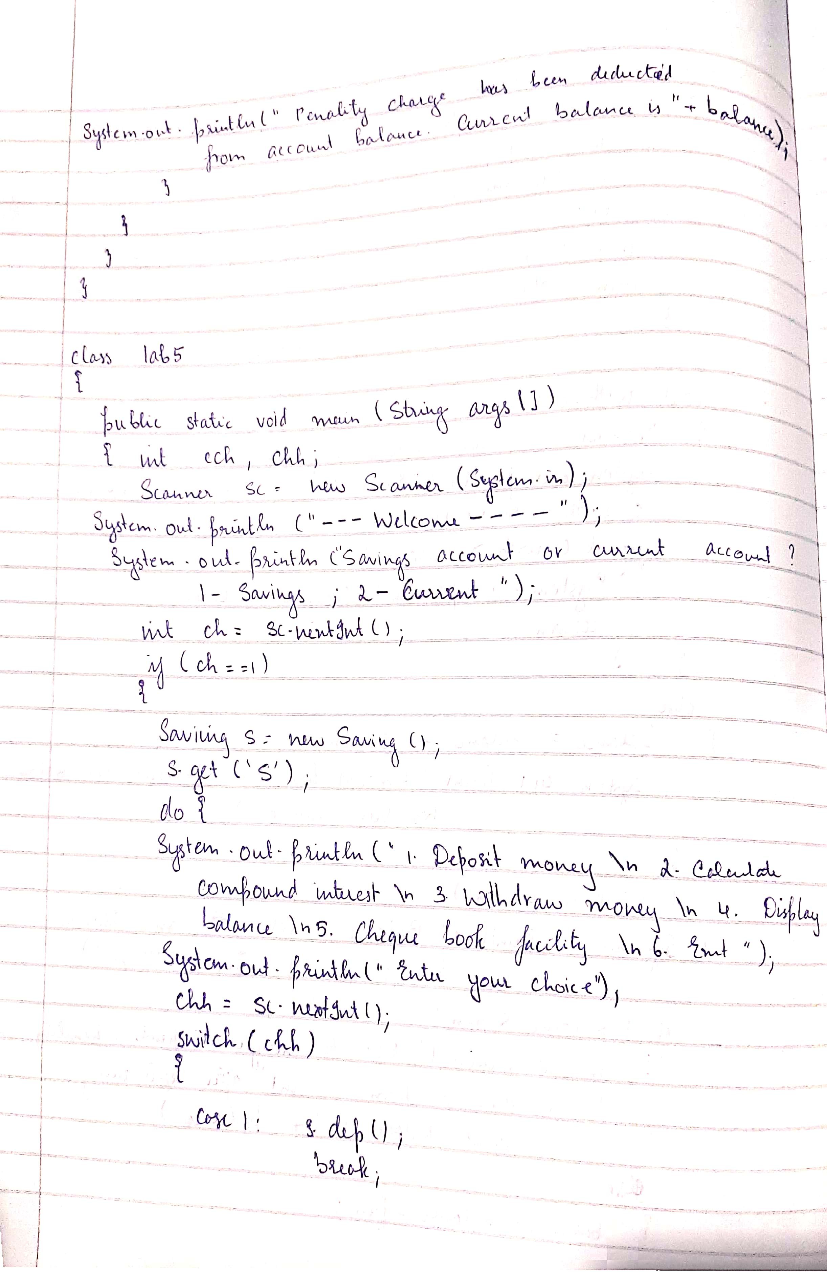

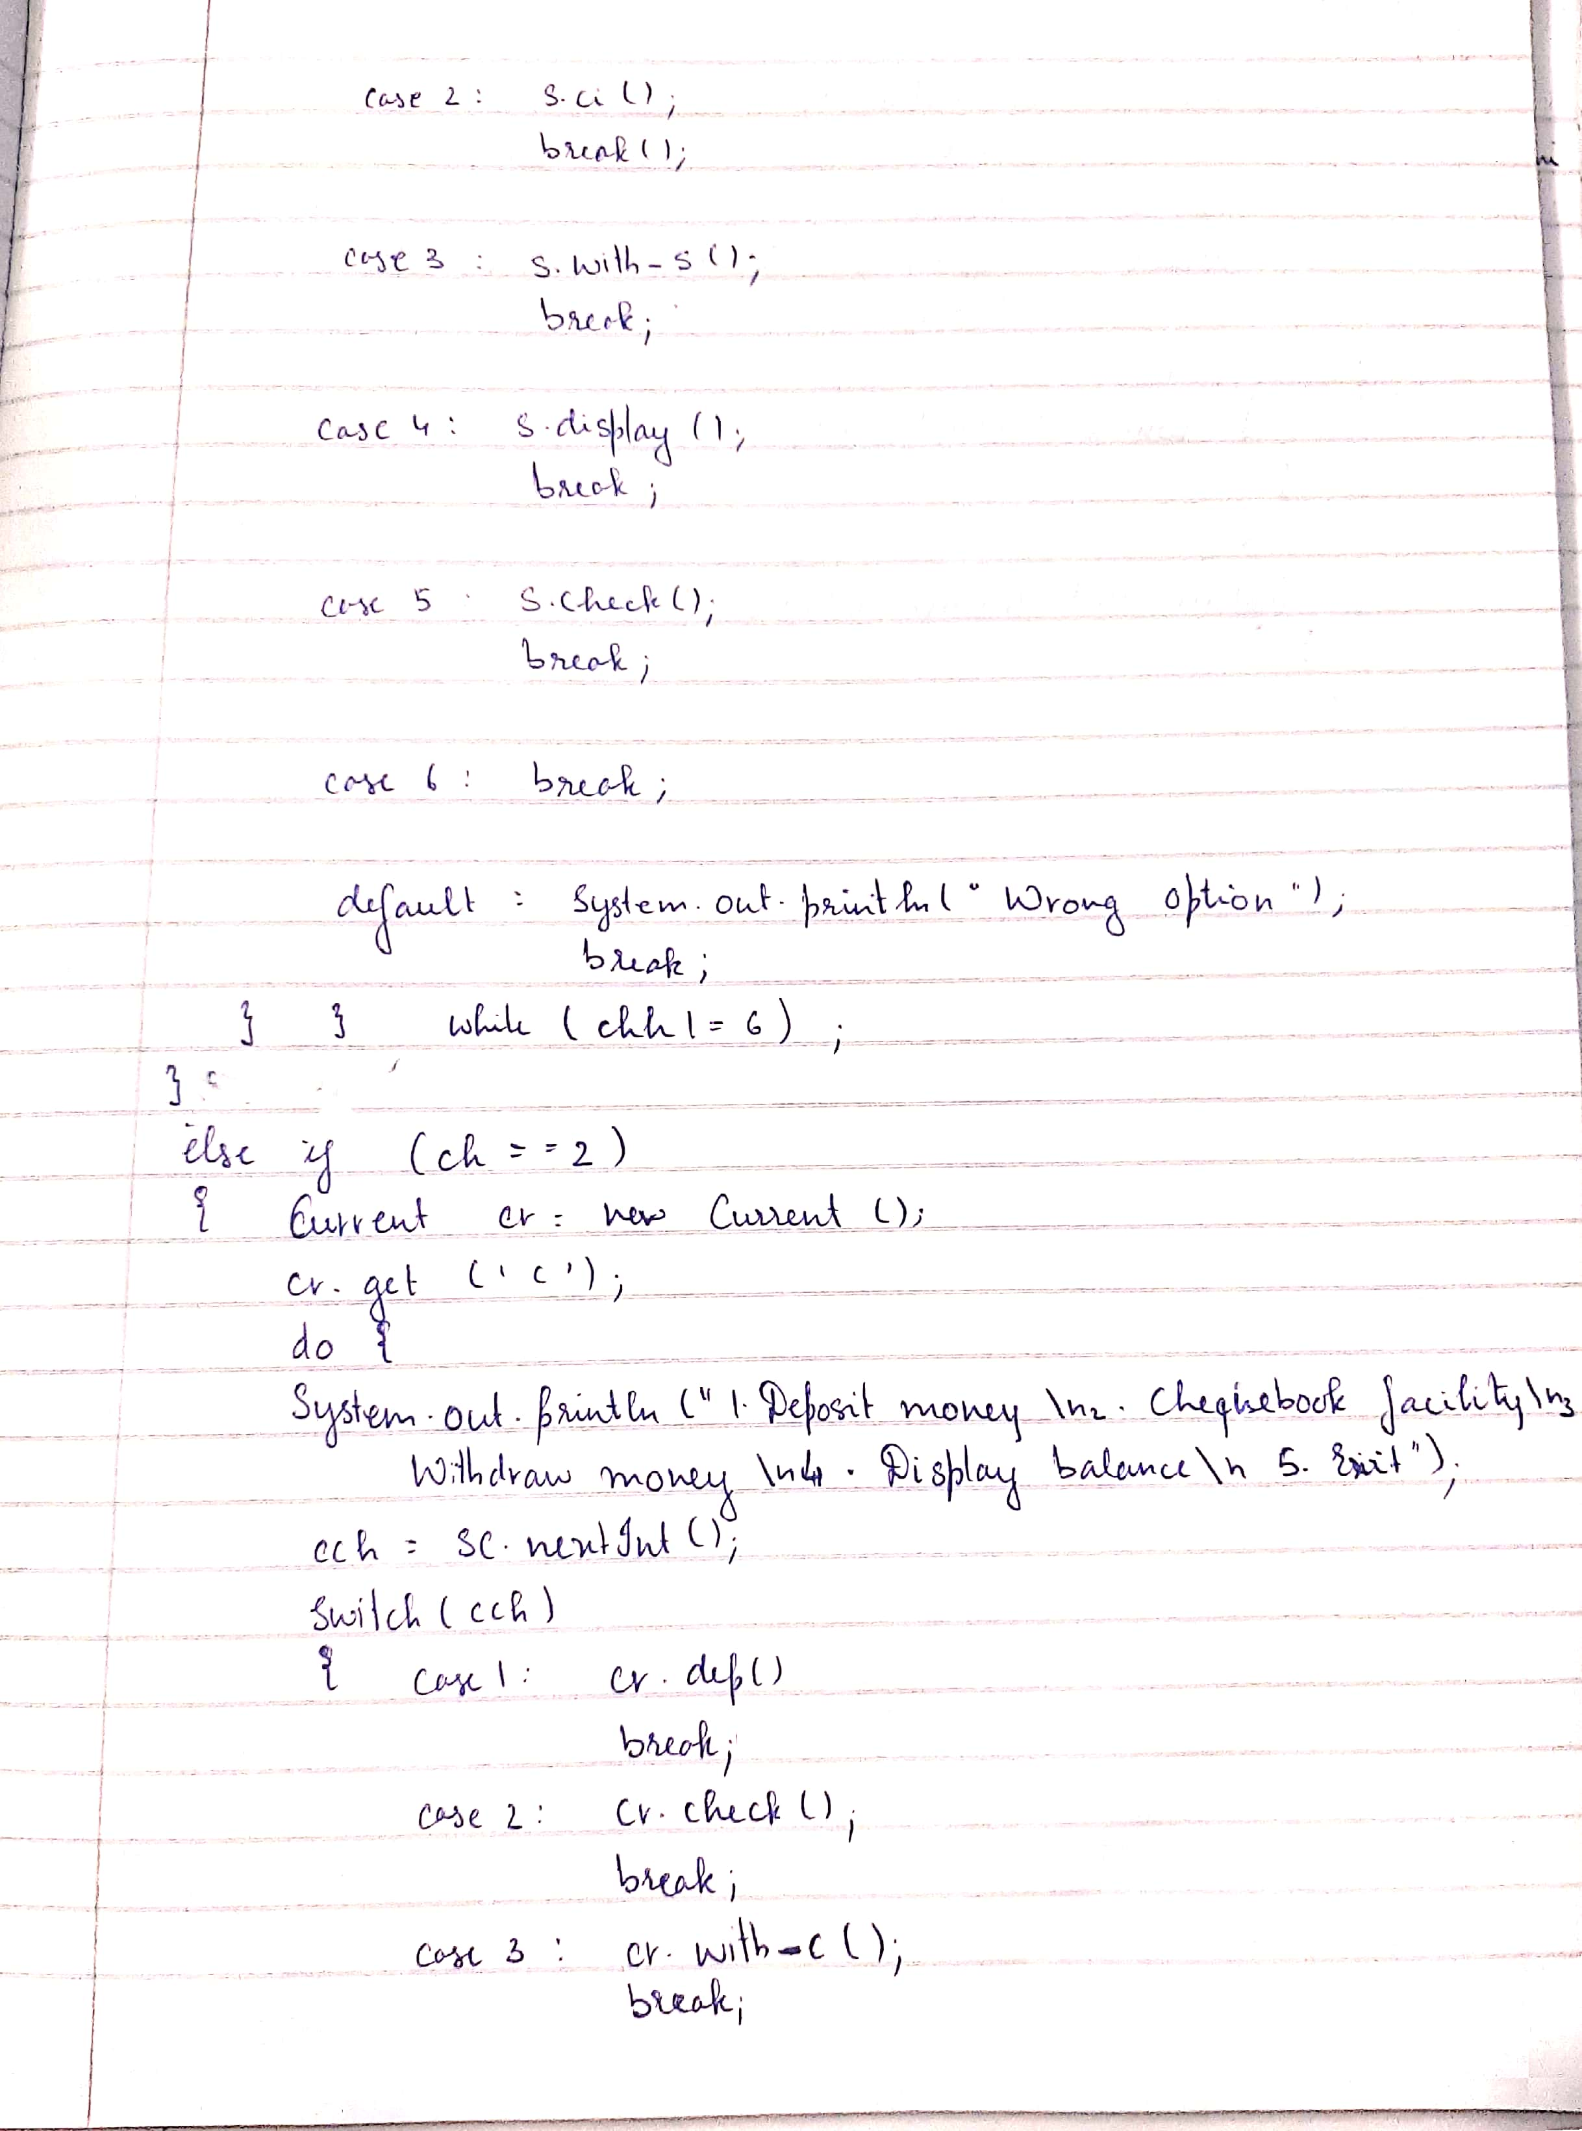

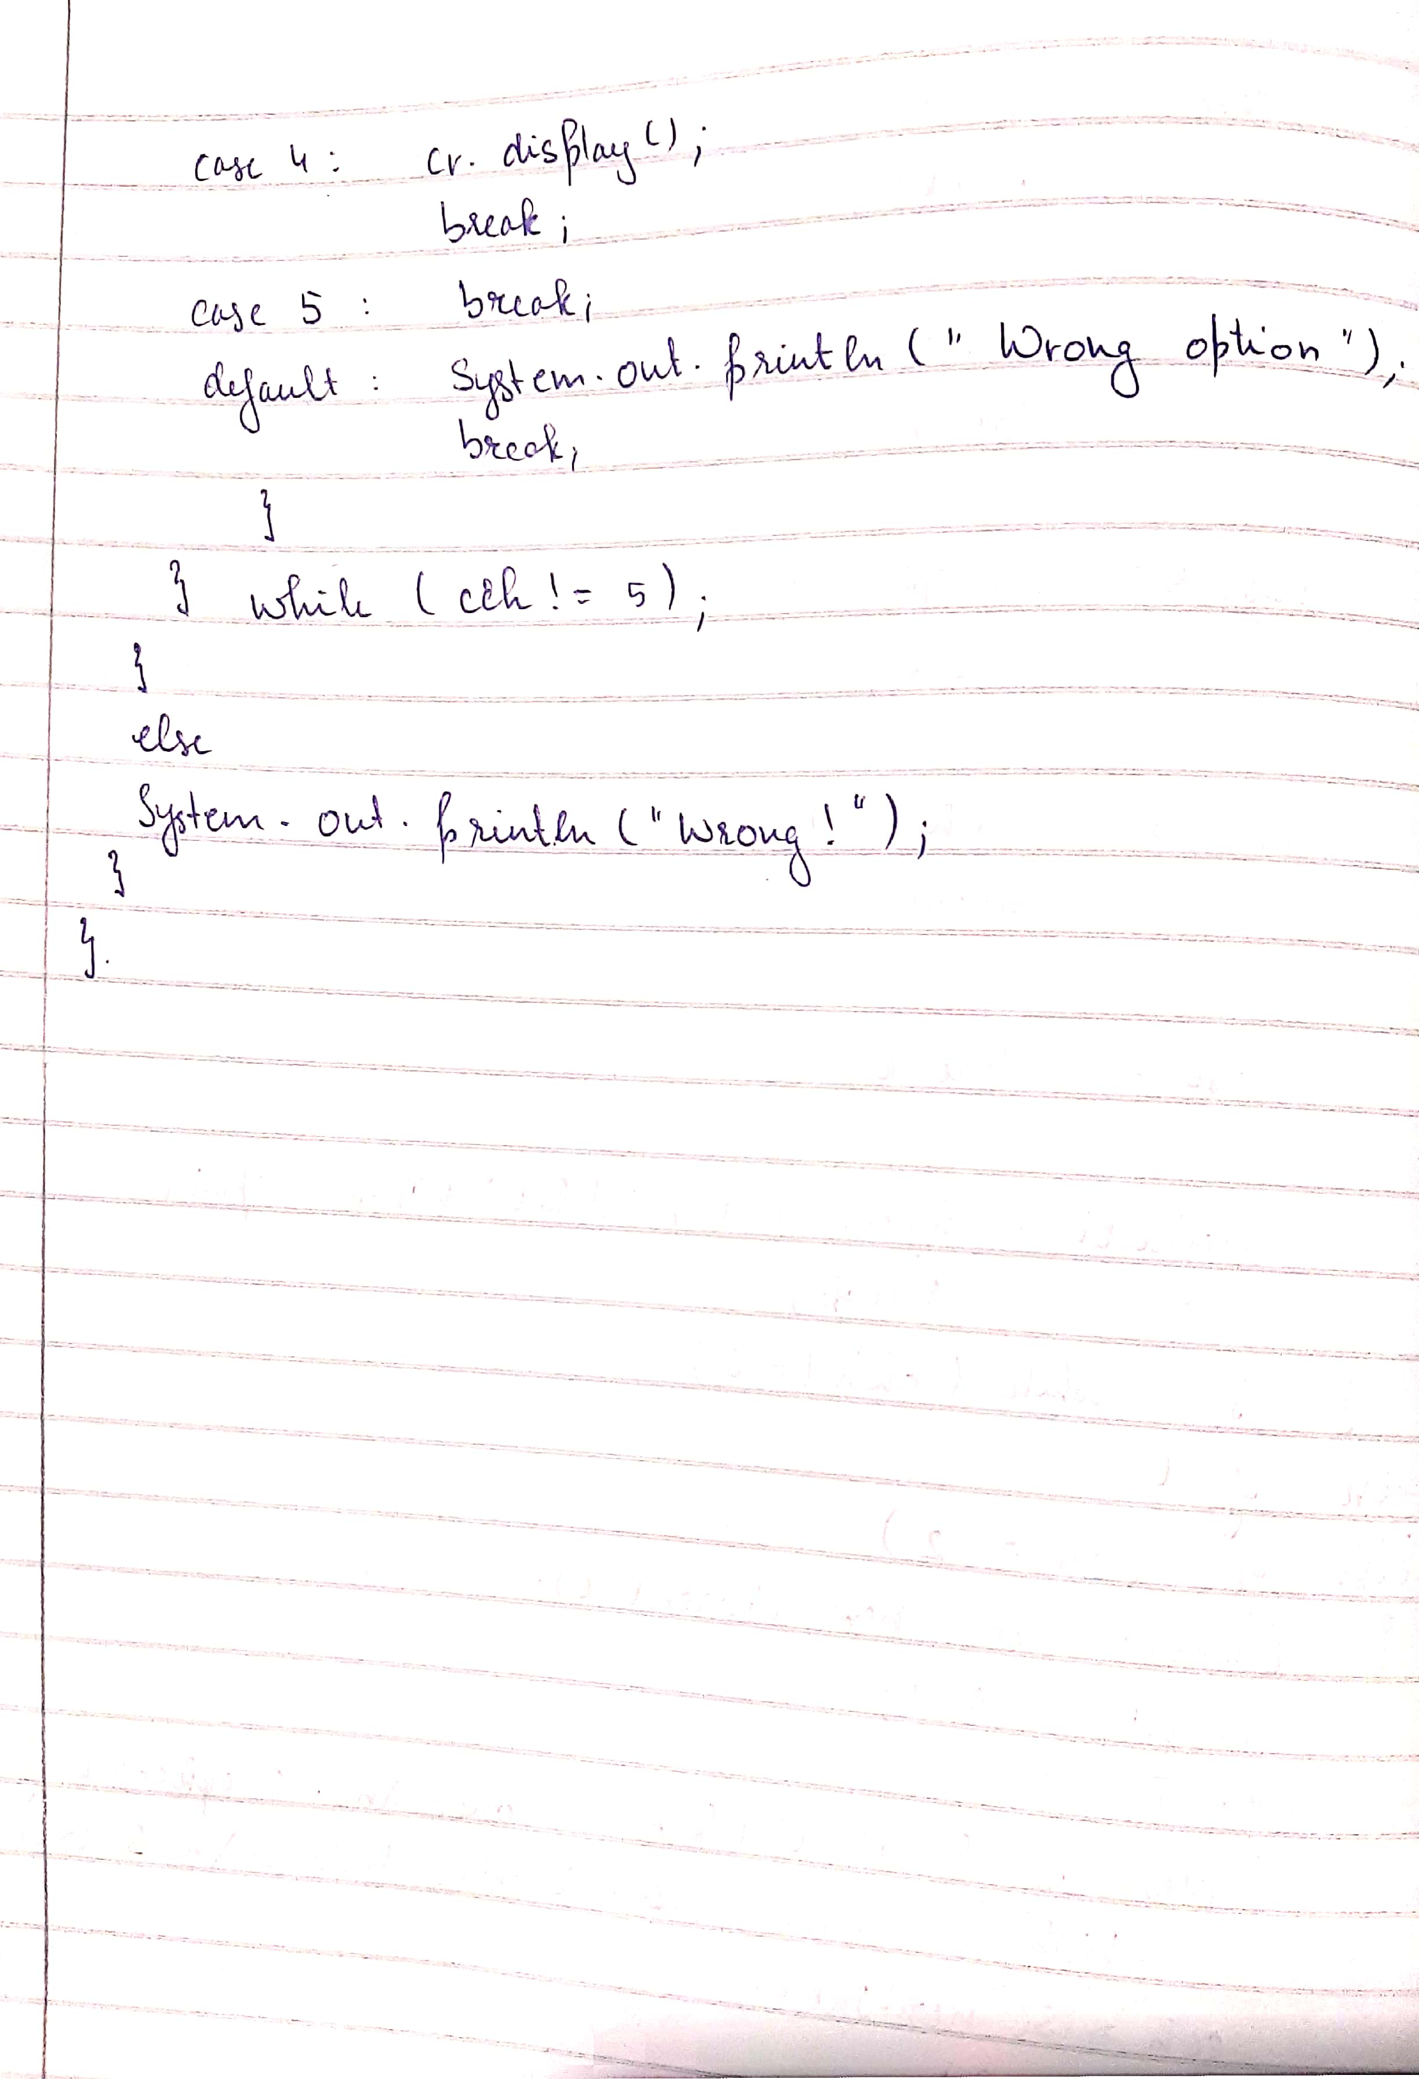

import java.util.*;

import java.lang.Math;

class Account

{

String name;

int acctno;

char type;

double balance;

double dep;

boolean cheq;

void get(char c)

{

type = c;

if(c=='s' || c == 'S')

cheq=false;

else cheq=true;

Scanner sc = new Scanner(System.in);

System.out.println("Enter your name");

name = sc.nextLine();

System.out.println("Enter the account number");

acctno = sc.nextInt();

System.out.println("Enter the current available balance in your account");

balance= sc.nextDouble();

}

void putd()

{

System.out.println("Account details");

System.out.println("Name: "+name);

System.out.println("Account number: "+acctno);

System.out.println("Account type :"+type);

System.out.println("balance: "+balance);

}

void dep()

{

Scanner ss = new Scanner(System.in);

System.out.println("Enter the amount to be deposited");

dep= ss.nextDouble();

balance=balance +dep;

System.out.println("Amount has been deposited and balance has been updated");

}

void display()

{

System.out.println("Balance amount is "+balance);

}

void check()

{

if(cheq==false)

System.out.println("Cheque book facility is not available");

else

System.out.println("Cheque book facility is available");

}

}

class Saving extends Account

{

double rate;

double s_with;

int n;

int ch;

double amt;

double term;

double pr;

void ci()

{

Scanner ss = new Scanner(System.in);

System.out.println("Enter principal deposit amount");

pr = ss.nextDouble();

System.out.println("Enter the rate of interest");

rate = ss.nextDouble();

System.out.println("Enter the term(years)");

term = ss.nextDouble();

System.out.println("Enter the number of times interest in compounded annually");

n = ss.nextInt();

amt = pr* Math.pow((1+(rate/100)),(n*term));

balance+= amt;

System.out.println("Interest is compounded and deposited; balance is updated");

}

void with_s()

{

Scanner ss = new Scanner(System.in);

System.out.println("Enter the amount of money to be withdrawn");

s_with = ss.nextDouble();

if(s_with>balance)

System.out.println("Insufficient balance");

else

{

balance= balance - s_with;

System.out.println("Money has been withdrawn and balance has been updated");

}

}

}

class Current extends Account

{

double c_with;

double pen;

double min;

Current()

{

pen=100;

min=500;

}

void with_c()

{

Scanner xx = new Scanner(System.in);

System.out.println("Enter the amount to be withdrawn");

c_with= xx.nextDouble();

if(c_with>balance)

{

System.out.println("Insufficient funds!");

return;

}

else

{

balance= balance- c_with;

System.out.println("Amount has been withdrawn and balance has been updated");

}

if(balance<min)

{

System.out.println("Balance is below the minimum threshold. Service penalty charge = 100/- .");

if(balance<pen)

System.out.println("Due to insufficient funds, penalty charge will be deducted from account after replenishing. Current balance is "+balance);

else

{

balance= balance-pen;

System.out.println("Penalty charge has been deducted from account balance. Current balance is "+balance);

}

}

}

}

class bank

{

public static void main(String sss[])

{

int cch, chh;

Scanner sx = new Scanner(System.in);

System.out.println("--------Welcome----------");

System.out.println("Savings account or current account? 1- Savings; 2- Current");

int ch= sx.nextInt();

if(ch==1)

{

Saving s = new Saving();

s.get('S');

do{

System.out.println("1. Deposit money\n2. Calculate compound interest\n3. Withdraw money\n4. Display balance\n5. Cheque book facility\n6. Exit");

System.out.println("Enter your choice");

chh= sx.nextInt();

switch(chh)

{

case 1:

s.dep();

break;

case 2:

s.ci();

break;

case 3:

s.with_s();

break;

case 4:

s.display();

break;

case 5:

s.check();

break;

case 6:

break;

default:

System.out.println("Wrong option.");

break;

}

}while(chh!=6);

}

else if(ch==2)

{

Current cr = new Current();

cr.get('C');

do{

System.out.println("1. Deposit money\n2. Chequebook facility\n3. Withdraw money\n4. Display balance\n5. Exit");

cch= sx.nextInt();

switch(cch)

{

case 1:

cr.dep();

break;

case 2:

cr.check();

break;

case 3:

cr.with_c();

break;

case 4:

cr.display();

break;

case 5:

break;

default:

System.out.println("Wrong option.");

break;

}

}while(cch!=5);

}

else System.out.println("Wrong!");

}

}

**OUTPUT**

